附件1(Appendix 1)：
2011中国职业高尔夫球锦标赛奖金分配表
2011 China PGA Championship Tour Prize Breakdown
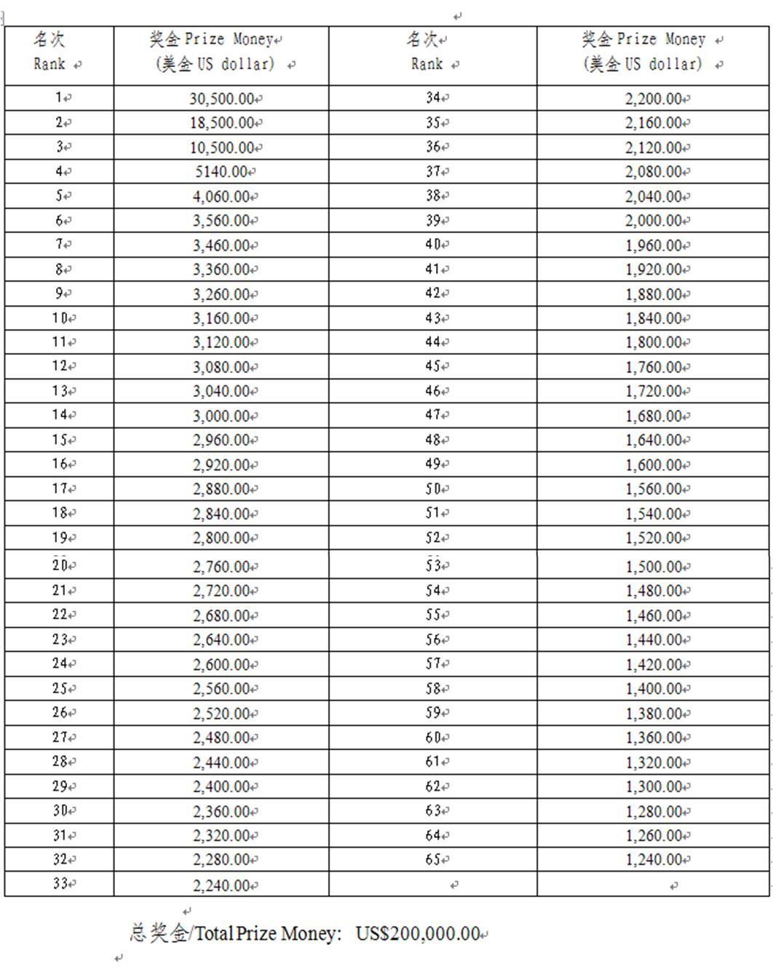

附件Appendix 2
2011年中国职业高尔夫球锦标赛(厦门)报名表
Entry form - 2011 China PGA Championship Tour Xiamen

主办球会：厦门凯歌高尔夫俱乐部 举办日期: 2011年9月22日- 25日
Host Venue: Xiamen kaikou Golf Club Date: 22st – 25th Sept. 2011
地址： 厦门市同安区同集路877号
Address: 887 Tongji Road, TongAn District, Xiamen, Fujian, China
参赛球员有义务自行查询报名结果，锦标赛组委会将不对在提交过程中遗失的报名表负责。
Player must confirm his entry with China PGA Championship Tour Organizing Committee. The Committee is not responsible for any missing entry request.
本人有兴趣参加在厦门凯歌高尔夫俱乐部举办的2011中国职业高尔夫球锦标赛厦门站的赛事。
I would like to join the 2011 China PGA Championship Tour at XIAMEN KAIKOU Golf Club
姓名  Name |  |  |  | 性别  Gender |  |  |  | 出生日期  Date of Birth |  |  |  | ______年/____月/____日  (YYYY/MM/DD)
电话  Tel |  |  |  | 手机  Mobile |  |  |  |  | 传真  Fax
证件类型  Type of Identification Document |  |  | - 球员证 Pro Player Card  - 教练证 Pro Coach Card |  |  |  | 证件号码  Card No.
官方指定酒店/  Official Hotel:  Xiamen Miramar Hotel  地址/Address：  Xinglong Road, Huli,  Xiamen |  | 房价/Room rates  □豪华房Deluxeroom:  RMB495/night (1 b’fast incl.)  RMB545/night (2 b’fasts incl.)  □行政房/Executive room  RMB595/night (1 b’fast incl.)  RMB645/night (2 b’fasts incl.)  Free internet and domestic call |  |  |  | 入住日期/  Check in date:  _____________  离店日期/  Check out date:  _____________ |  |  |  |  | 如入住组委会指定酒店，请打在相应房型上划勾确认。以便组委会确认订房要求，安排比赛期间接送。  Should a player requst a room at this hotel, please tick the corresponding room type. The organizing committle will confirm all booking with the hotel for all players. Free shuttle bus between the official hotel and the golf course will be available during the tournament.
开户银行名称  Bank Name |  |  |  |  |  | 帐户名称  Account Name
分行名称  Branch Name |  |  |  |  |  | 帐号  Account No.
Swift Code |  |  |  |  |  | 球僮要求  Caddie Request |  |  |  |  | □ 自带球童 Private Caddy  □ 球会球童 Club Caddie
奖金将会按照此次报名表上填写的银行信息汇出，如您的账号出现任何问题需要重新汇款，所需手续费用将从您的奖金中扣除。
Prize money will be transferred to the bank account provided in this entry form. Any bank charges incurred from payment return due to incorrect banking details will be deducted from the prize money before sending again.
注: 我保证以上提供的资料真实有效，根据中国高尔夫球协会的有关规定，我具有中国高尔夫球协会职业身份。赛事主办单位保留权力，在必要的时，要求球员出具相关证明材料。中国高尔夫球协会对参赛球员的资格及参赛申请有最终决定权。
Note: I certify that all the information given in this form is true to the best of my knowledge. According to the rules and regulations of China Golf Association, I am a PGA member (or a qualified amateur). China Golf Association reserves its right to require or request certification from all players and decline any entry request at any stage of the tournament.

（球员签名/Signature）

报名截止日期：2011年9月12日晚上12:00整。请将此表格电邮或传真至北京东铭国际体育发展有限公司，email: cpgatour@gmail.com
传真： 010-65523881. 报名确认电话：010-65519962,
Entry will be closed at midnight on 8^{h} Sep2011. Please send this form to DYM International Sports Development Co.,Ltd by fax: +8610-65523881 or
email: cpgatour@gmail.com. Call Tel: +8610-65539662 for entry confirmation.

